**CMSC 335**

**Herman Mann**

**Project - 1**

**User Guide, Test Plan, UML and Lesson Learned**

**03/27/2022**

**Contents**

**Introduction** 3

**Overview** 4

**Design** 6

**Test Cases** 7

**Test Case #1: Menu option 1 - Construct a Circle** 7

**Test Case #2: Menu option 2 - Construct a Rectangle** 8

**Test Case #3: Menu option 3 - Construct a Square** 9

**Test Case #4: Menu option 4 - Construct a Triangle** 10

**Test Case #5: Menu option 5 - Construct a Sphere** 11

**Test Case #6: Menu option 6 - Construct a Cube** 12

**Test Case #7: Menu option 7 - Construct a Cone** 13

**Test Case #8: Menu option 8 - Construct a Cylinder** 14

**Test Case #9: Menu option 9 - Construct a Torus** 15

**Test Case #10: Menu option 10 – Exit the program** 16

**Test Case #11: Wrong Menu option – Error Handling** 17

**Test Case #12: Wrong Continue Option – Error Handling** 18

**Setup and Run Application** 19

**Lesson Learned** 20

# **Introduction**

This is the project of the Class 335. In this project, I have designed and implemented a parent Shape class that is extended by the TwoDimensionalShape and ThreeDimensionalShape classes with respective fields and methods such as to calculate the area and volume of the shape. In addition, the TwoDimensionalShape class is also extended by the square, triangle, rectangle and circle classes to override the calculate area methods to get the actual value of the area for the corresponding shape. Similarly, the ThreeDimensionalShape class is also extended by the cube, sphere, cone, cylinder and torus classes to override the calculate volume methods to get the actual value of the volume for the corresponding shape. Classes are properly implemented using the inheritance and polymorphism concepts of Object Orientated Programming. Project has a text based application (NOT a GUI based one). Code is written in Java programming language. User can choose a menu option and perform the desired operations of the specific shape by entering the desired selection of menu option. User can see the printed resulted of each selected operation of the shape.

# **Overview**

This project is implement using Java programming language. In this project, I created the following classes using the inheritence and polymorphism OOP concepts.

1. AppResources - Class to handle application resources
2. Shape - Class to handle the shape related fields and methods
3. TwoDimensionalShape - Class to extend the shape class and handle methods and field to get area and calculare area of the shape
4. ThreeDimensionalShape- Class to extend the shape class and handle methods and field to get volume and calculare volume of the shape
5. Circle- Class to extend the TwoDimensionalShape class and override the calculate area of the circle
6. Sqaure- Class to extend the TwoDimensionalShape class and override the calculate area of the square
7. Rectangle- Class to extend the TwoDimensionalShape class and override the calculate area of the rectangle
8. Triangle- Class to extend the TwoDimensionalShape class and override the calculate area of the triangle
9. Cone- Class to extend the ThreeDimensionalShape class and override the calculate volume of the cone
10. Cube- Class to extend the ThreeDimensionalShape class and override the calculate volume of the cube
11. Cylinder- Class to extend the ThreeDimensionalShape class and override the calculate volume of the cylinder
12. Sphere- Class to extend the ThreeDimensionalShape class and override the calculate volume of the sphere
13. Torus- Class to extend the ThreeDimensionalShape class and override the calculate volume of the torus
14. Project1 – Class to control handle and print the menu option as per the text based user interface.

# **Design**

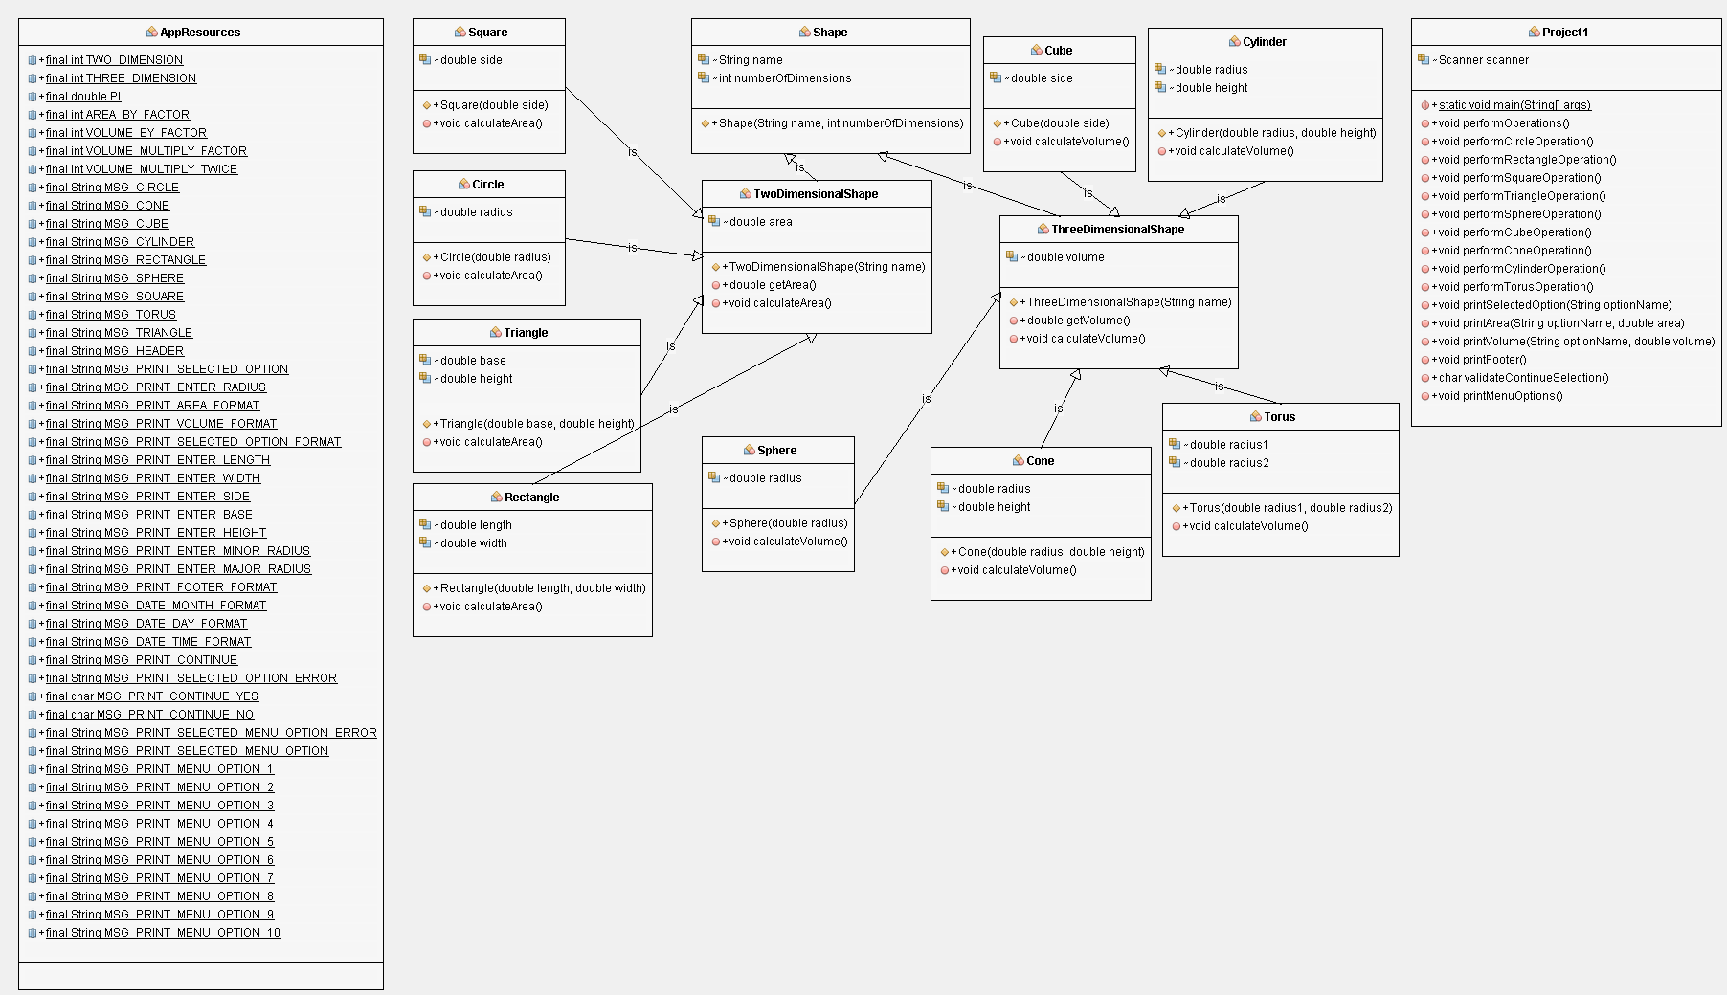

# **Test Cases**

|  |  |
| --- | --- |
| **Test Case #1: Menu option 1 - Construct a Circle** | |
| **Description** | To construct a circle and print area of the circle |
| **Input** | Radius of circle = 8 |
| **Expected Result** | The area of the Circle is 200.96 |
| **Actual Result** | The area of the Circle is 200.96 |
| **Pass** | **Yes** |
| **Screenshot** |  |

|  |  |
| --- | --- |
| **Test Case #2: Menu option 2 - Construct a Rectangle** | |
| **Description** | To construct a Rectangle and print area of the Rectangle |
| **Input** | Length = 2  Width = 4 |
| **Expected Result** | The area of the Rectangle is 8.00 |
| **Actual Result** | The area of the Rectangle is 8.00 |
| **Pass** | **Yes** |
| **Screenshot** |  |

|  |  |
| --- | --- |
| **Test Case #3: Menu option 3 - Construct a Square** | |
| **Description** | To construct a Square and print area of the Square |
| **Input** | Side = 2 |
| **Expected Result** | The area of the Square is 4.00 |
| **Actual Result** | The area of the Square is 4.00 |
| **Pass** | **Yes** |
| **Screenshot** |  |

|  |  |
| --- | --- |
| **Test Case #4: Menu option 4 - Construct a Triangle** | |
| **Description** | To construct a Triangle and print area of the Triangle |
| **Input** | Base = 2  Height = 4 |
| **Expected Result** | The area of the Triangle is 4.00 |
| **Actual Result** | The area of the Triangle is 4.00 |
| **Pass** | **Yes** |
| **Screenshot** |  |

|  |  |
| --- | --- |
| **Test Case #5: Menu option 5 - Construct a Sphere** | |
| **Description** | To construct a Sphere and print volume of the Sphere |
| **Input** | Radius = 2 |
| **Expected Result** | The volume of the Sphere is 25.12 |
| **Actual Result** | The volume of the Sphere is 25.12 |
| **Pass** | **Yes** |
| **Screenshot** |  |

|  |  |
| --- | --- |
| **Test Case #6: Menu option 6 - Construct a Cube** | |
| **Description** | To construct a Cube and print volume of the Cube |
| **Input** | Radius = 2 |
| **Expected Result** | The volume of the Cube is 8.00 |
| **Actual Result** | The volume of the Cube is 8.00 |
| **Pass** | **Yes** |
| **Screenshot** |  |

|  |  |
| --- | --- |
| **Test Case #7: Menu option 7 - Construct a Cone** | |
| **Description** | To construct a Cone and print volume of the Cone |
| **Input** | Radius = 2  Height = 4 |
| **Expected Result** | The volume of the Cone is 16.75 |
| **Actual Result** | The volume of the Cone is 16.75 |
| **Pass** | **Yes** |
| **Screenshot** |  |

|  |  |
| --- | --- |
| **Test Case #8: Menu option 8 - Construct a Cylinder** | |
| **Description** | To construct a Cylinder and print volume of the Cylinder |
| **Input** | Radius = 2  Height = 4 |
| **Expected Result** | The volume of the Cylinder is 50.24 |
| **Actual Result** | The volume of the Cylinder is 50.24 |
| **Pass** | **Yes** |
| **Screenshot** |  |

|  |  |
| --- | --- |
| **Test Case #9: Menu option 9 - Construct a Torus** | |
| **Description** | To construct a Torus Sphere and print volume of the Torus |
| **Input** | Minor Radius = 2  Major Radius = 4 |
| **Expected Result** | The volume of the Torus is 315.51 |
| **Actual Result** | The volume of the Torus is 315.51 |
| **Pass** | **Yes** |
| **Screenshot** |  |

|  |  |
| --- | --- |
| **Test Case #10: Menu option 10 – Exit the program** | |
| **Description** | To exit the program |
| **Input** | Menu option 10 |
| **Expected Result** | Application exit and print thank you message |
| **Actual Result** | Application exit and print thank you message |
| **Pass** | **Yes** |
| **Screenshot** |  |

|  |  |
| --- | --- |
| **Test Case #11: Wrong Menu option – Error Handling** | |
| **Description** | To handle error message for wrong menu option |
| **Input** | Wrong Menu Option 12 |
| **Expected Result** | Print error message |
| **Actual Result** | Error - Menu choice is wrong. Please Enter choice between 1 to 10 |
| **Pass** | **Yes** |
| **Screenshot** |  |

|  |  |
| --- | --- |
| **Test Case #12: Wrong Continue Option – Error Handling** | |
| **Description** | To handle error message for wrong continue option |
| **Input** | Wrong Continue Option 14 |
| **Expected Result** | Print error message |
| **Actual Result** | Sorry I do not understand. Enter Y or N |
| **Pass** | **Yes** |
| **Screenshot** |  |

# **Setup and Run Application**

1. Download the project zip file
2. Open the NetBeans IDE
3. Under File menu option, Select Import Project from ZIP
4. Choose the project zip file location from file chooser dialog box and click import button
5. Project will be imported in NetBeans
6. Compile the project
7. Run the project

# **Lesson Learned**

During the design and implementaion of this project, I have learned a lots of new things about the Object Oriented Programming Languages. Here are few implmetation done in this projects

* Coded all the classes in Java with advanced concepts of OOPs
* Application resources are maintained in as share class
* Inheritence and polymorphism concepts are used with the help of extends, super and override keywords
* Project is written in resuseable code manner
* A modular approach of coding is used for the implementation of the classes
* Step by step executation of the application methods are implemented as per the requirement of text based user interface.
* Error and Exception handling is properly implemented